Part 1: Theoretical Analysis (30%)

1. Short Answer Questions

Q1: Explain how AI-driven code generation tools (e.g., GitHub Copilot) reduce development time. What are their limitations?
Answer:
AI-driven code generation tools like GitHub Copilot leverage machine learning models trained on large code repositories to provide real-time suggestions while developers write code. They reduce development time by:
- Auto-completing code snippets – Developers can write less boilerplate code manually.
- Suggesting functions and algorithms – Copilot can propose entire functions or class structures based on context.
- Accelerating debugging and refactoring – It can suggest corrections or improvements to existing code.
- Reducing context switching – Developers spend less time searching documentation or Stack Overflow.
Limitations:
- Accuracy issues: The suggested code may contain bugs or security vulnerabilities.
- Context misunderstanding: Copilot may propose irrelevant solutions if it misinterprets the developer’s intent.
- Dependency on large datasets: Suggestions are influenced by training data, which may include outdated or non-optimal practices.
- Licensing concerns: Some generated code may resemble copyrighted code, raising intellectual property questions.
Summary: AI tools boost productivity but still require human oversight to ensure correctness, security, and maintainability.

Q2: Compare supervised and unsupervised learning in the context of automated bug detection.
Answer:
AI can use both supervised and unsupervised learning approaches for automated bug detection:
- Supervised Learning:
  - Uses labeled datasets containing code examples annotated as “buggy” or “clean.”
  - Models learn patterns that differentiate correct code from code containing bugs.
  - Advantages: High accuracy with good labeled data; predictable behavior.
  - Limitations: Requires large, manually labeled datasets; may not detect novel bugs unseen in training data.
- Unsupervised Learning:
  - Works with unlabeled code to identify anomalies or unusual patterns that may indicate bugs.
  - Techniques include clustering and anomaly detection.
  - Advantages: Can detect previously unknown or rare bugs; no need for labeled datasets.
  - Limitations: Higher false-positive rate; results are less interpretable; may flag normal code as buggy.
Summary: Supervised learning excels with known bug patterns, while unsupervised learning is useful for discovering new or unexpected defects. Combining both approaches can improve overall bug detection coverage.

Q3: Why is bias mitigation critical when using AI for user experience personalization?
Answer:
Bias mitigation is essential in AI-driven personalization because these systems influence what content, products, or recommendations users see. Without mitigation:
- Unfair experiences: Biased algorithms may favor certain user groups over others, leading to discrimination.
- Reinforcement of stereotypes: AI can amplify existing societal biases in the data, negatively impacting underrepresented groups.
- Reduced engagement and trust: Users may feel ignored or unfairly treated, harming adoption and satisfaction.
- Legal and ethical risks: Non-compliant AI systems may violate privacy and anti-discrimination regulations.
Conclusion: Mitigating bias ensures AI personalization is fair, ethical, and inclusive, improving both user trust and business outcomes
Q: How does AIOps improve software deployment efficiency? Provide two examples.
Answer:
AIOps (Artificial Intelligence for IT Operations) leverages machine learning, big data analytics, and automation to improve software deployment efficiency by detecting issues early, optimizing processes, and reducing manual intervention. It allows IT teams to deploy updates faster, with fewer errors and minimal downtime.
Examples:
- Automated Anomaly Detection:
  - AIOps tools can analyze system logs and performance metrics in real time to detect unusual patterns before they cause deployment failures.
  - Example: Before deploying a new feature, an AIOps platform detects that a recent database change could cause latency spikes and alerts the team, preventing potential rollback.
- Intelligent Deployment Automation:
  - AIOps can automate deployment pipelines and rollback procedures based on predictive insights.
  - Example: During a software update, AIOps predicts which servers are likely to fail under load and automatically reroutes traffic or schedules staged deployments, ensuring smoother rollout.
Summary: By combining predictive analytics and automated actions, AIOps reduces downtime, prevents errors, and accelerates deployment cycles, improving overall software delivery efficiency.

AI-Powered Code Completion
The task of sorting a list of dictionaries in Python can be approached in multiple ways. The manual implementation, defined as sort_list_of_dicts(lst, key, reverse=False), uses the built-in sorted() function with a lambda function accessing the key directly. This approach is simple and concise, making it suitable for small, controlled datasets where all dictionaries are guaranteed to contain the specified key. However, it has several limitations: it raises a KeyError if a dictionary lacks the key, and it cannot handle mixed data types safely. Additionally, the function lacks documentation and error handling, which reduces its suitability for production-level code.
In contrast, the AI-suggested implementation enhances robustness and usability. It uses d.get(key, None) to handle missing keys safely, ensuring that dictionaries without the key do not cause errors. It also includes a fallback using string conversion to handle type inconsistencies gracefully. The function allows both ascending and descending sorting through the reverse parameter and returns a new sorted list without modifying the original. Comprehensive documentation provides clear instructions on usage, arguments, and return values. Overall, while the manual implementation is sufficient for simple tasks, the AI-suggested code is more versatile, fault-tolerant, and suitable for real-world applications where datasets may be inconsistent or incomplete.

Automated Testing with AI
I used a small AI tester plugin to automate logging into a webpage, and the test was successful. The plugin efficiently navigated the login form, entered credentials, and submitted the information without manual effort. This demonstrates how AI-driven testing tools can save time, reduce repetitive tasks, and streamline processes like login verification, regression testing, and interface validation. The experience showed the potential of AI plugins to accelerate development and testing workflows, even in small-scale scenarios.
However, giving such plugins access to passwords carries inherent risks. If the plugin or the system it runs on is compromised, credentials could be exposed, leading to unauthorized access. Some plugins may also cache or log sensitive data, increasing potential vulnerabilities. To mitigate these dangers, it is essential to store passwords securely using environment variables, encrypted vaults, or password managers, and only grant access to trusted automation tools. While AI tester plugins are powerful, careful handling of sensitive data is critical to maintaining security.



Task 3: Predictive Analytics for Resource Allocation

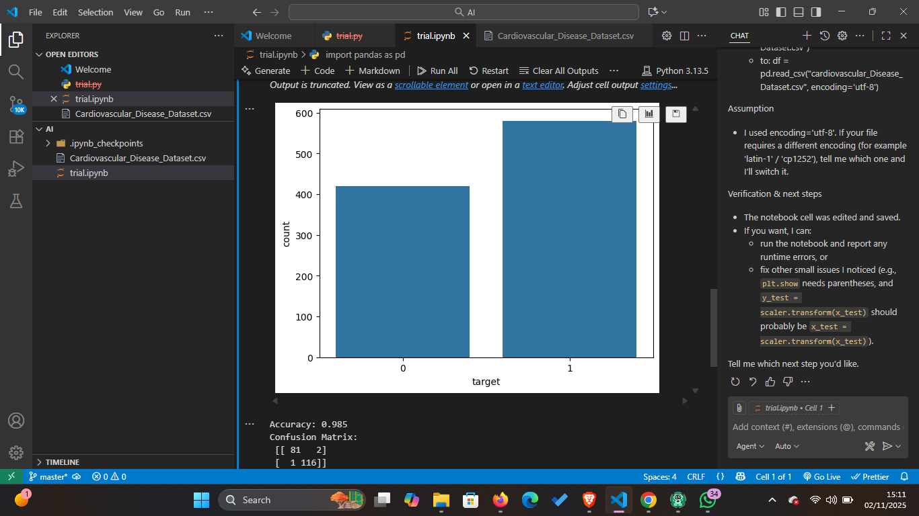
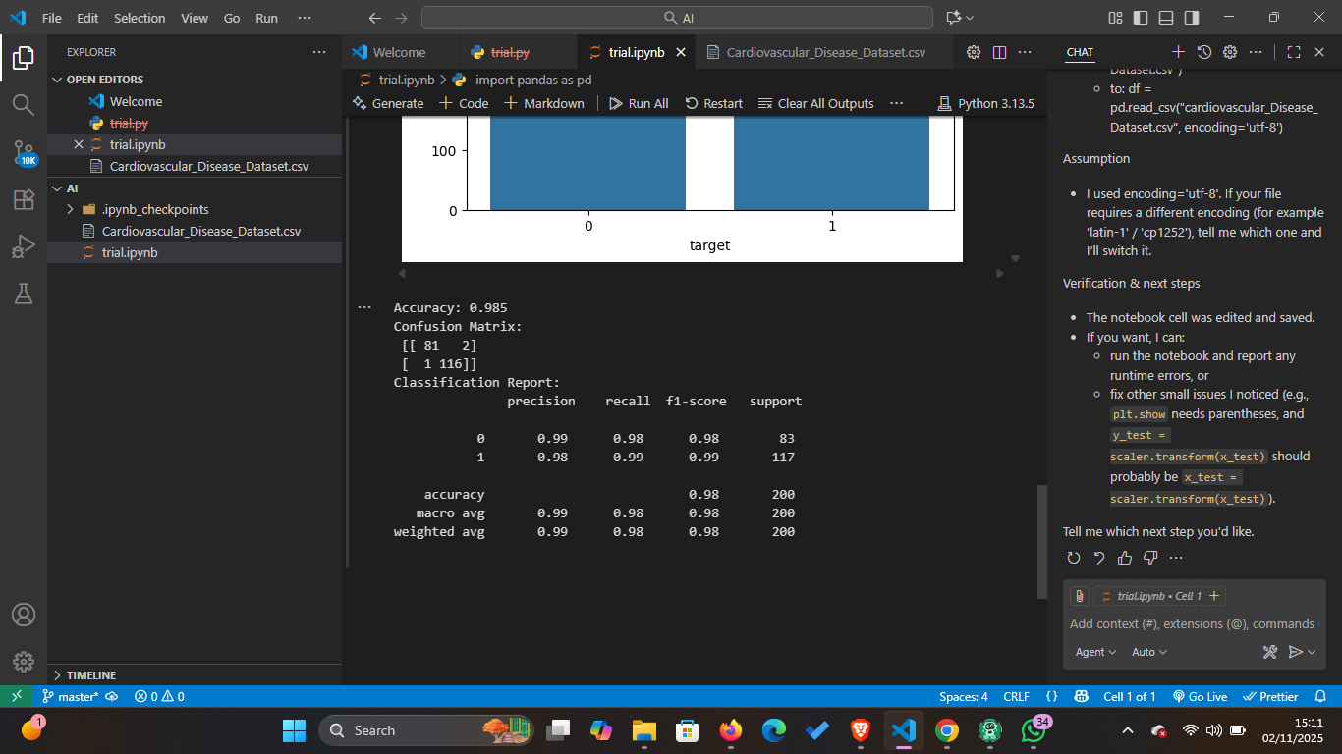

Ethical Reflection

Discussion: Potential Biases and Fairness in Predictive Models
In deploying a predictive model for cardiovascular or heart disease risk, potential biases in the dataset must be carefully considered. One major source of bias could be underrepresented groups, such as specific age ranges, genders, ethnicities, or patients from particular geographic regions. If the training dataset disproportionately represents one demographic, the model may perform well for that group but inaccurately predict outcomes for underrepresented populations. For example, if most records are from middle-aged males, the model may underestimate risk for females or older adults, leading to unfair or unsafe predictions.
To address such biases, fairness tools like IBM AI Fairness 360 (AIF360) can be applied. These tools provide metrics to detect bias in model predictions and datasets, and algorithms to mitigate it. Techniques include reweighing samples, preprocessing data to balance representation, post-processing predictions to ensure equitable outcomes, or adversarial debiasing during training. Applying these methods ensures the model makes fair, unbiased predictions, improving reliability and ethical compliance in clinical decision-making.
Summary: Identifying biases and using fairness tools like AIF360 helps build models that are accurate and equitable, reducing risks of harm to underrepresented groups.

